Data Link / 2 Layer
VLAN  Purpose: Segments one physical LAN into multiple logical broadcast domains. | 802.1Q / Native VLAN:  Switches add an 802.1Q tag to trunk frames to identify the VLAN. Frames on the native VLAN are sent untagged. Untagged frames received on a trunk are placed in the native VLAN. Tags are removed before frames are sent to end hosts. | Ports / DTP:  Access carries one VLAN only.  Trunk carries multiple VLANs.  DTP negotiates whether a link becomes an access link or trunk.  Dynamic desirable actively tries to form a trunk.  Dynamic auto waits for the other side to initiate.  Two dynamic auto ports do not form a trunk.
Inter-VLAN Routing:
Traffic cannot move between VLANs through Layer 2 switching alone. Communication between VLANs requires a Layer 3 device, such as a router or Layer 3 switch.
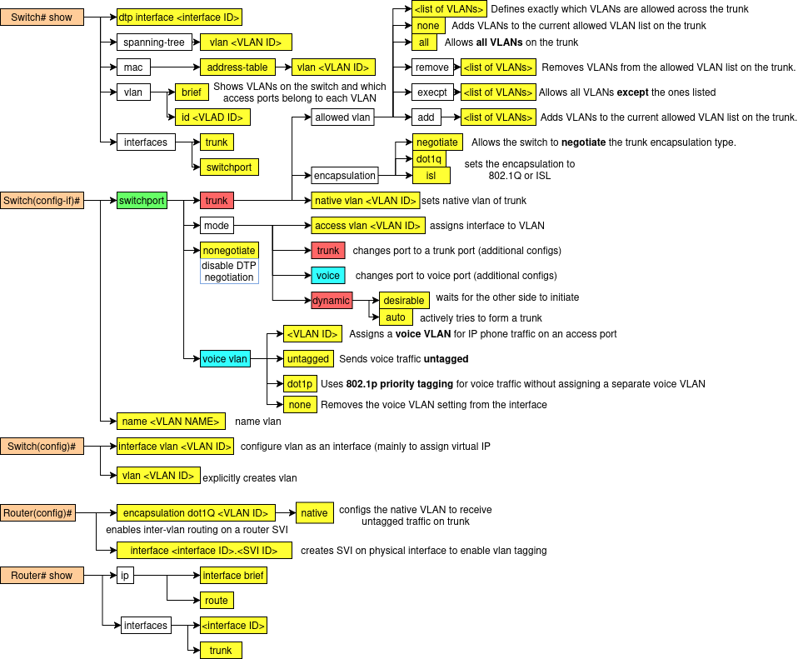

Rapid Spanning Tree Protocol (RSTP)  Purpose: Prevents Layer 2 loops and broadcast storms by placing redundant links into a non-forwarding state when needed. | Port States:  Discarding: does not forward frames and does not learn MAC addresses; used to prevent loops while waiting or blocking.  Learning: does not forward frames yet, but starts learning source MAC addresses to build the MAC table.  Forwarding: fully operational state; forwards frames and learns MAC addresses. | Root Election / Path Selection Process: 1) Elect Root Bridge by choosing the switch with the lowest Bridge ID.  2) Bridge ID is compared by priority first, then MAC address if priorities are equal.  3) Each non-root switch selects one Root Port, which is the port with the lowest total path cost to the root bridge.  4) On each network segment, one Designated Port is chosen as the port that sends the best BPDU onto that segment.  5) Any other redundant ports on that segment become Alternate ports to prevent loops.  6) If the active path fails, an alternate port can quickly transition to forwarding.
Port Roles:
Root Port: the best port on a non-root switch that points toward the root bridge.
Designated Port: the port allowed to forward traffic for a segment because it has the best path from that segment to the root.
Alternate Port: a backup path toward the root bridge; normally kept in a non-forwarding state unless needed.
Disabled: administratively down or unusable, so it does not participate in STP operations.
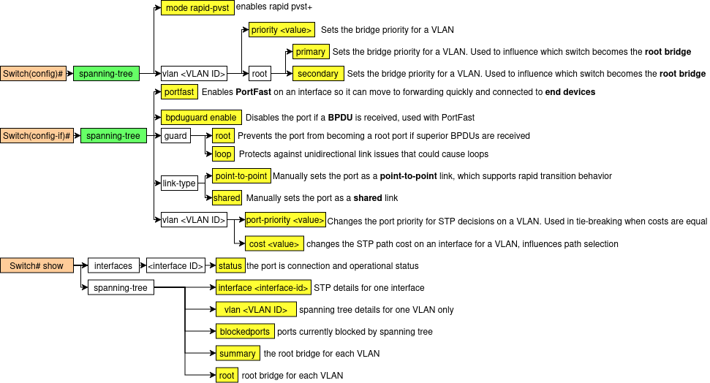

First-Hop Redundency Protocol (FHRP)/  Host Standby Router Protocol (HSRP)  Purpose: Provides default gateway redundancy so hosts can still reach other networks if one router fails. |  | Operation Process:  1) Routers join the same HSRP group.  2) The group uses a virtual IP and virtual MAC.  2) One router becomes active and forwards traffic.  3) One router becomes standby and waits to take over.  4) Hosts use the virtual IP as their default gateway.  5) The active router sends hello messages.
Election Behavior:  Highest priority becomes active. If tied, highest IP address wins. Next best router becomes standby. Preemption lets a higher-priority router retake the active role. | Failure Process:  If the standby router stops receiving hello messages, it assumes the active router has failed and becomes the new active router. It then sends a gratuitous ARP so hosts update the gateway MAC entry and continue forwarding with minimal disruption.
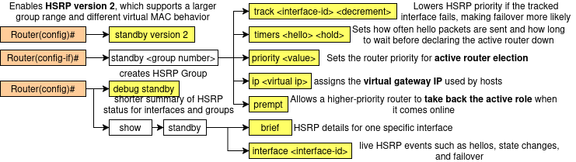

EtherChannel / Port-Channel  Purpose: Combines multiple physical links into one logical link to increase bandwidth and provide redundancy. | Channel Types:  1) Static configuration  2) Port Aggregation Protocol (PagP)  3) Link Aggregation Control Protocol (LACP) – IEEE 802.3ad |  | Negotiation Modes:  PAgP desirable: actively tries to form the channel.  PAgP auto: waits for the other side to initiate.  LACP active: actively tries to form the channel.  LACP passive: waits for the other side to initiate.
Failure / STP:  If one link fails, traffic uses the remaining links. The EtherChannel fails only if all member links fail. STP treats it as one logical link, reducing blocked redundant links. |  | Negotiation Modes:  PAgP: desirable initiates, auto waits.  LACP: active initiates, passive waits.  Formation Behavior:  Forms with on + on, desirable + auto, and active + passive.  Does not form with auto + auto or passive + passive.
Load Balancing / Operation:
Traffic is balanced across member links based on a hash such as source/destination MAC or IP. Frames in the same flow usually stay on the same physical link to avoid out-of-order delivery.
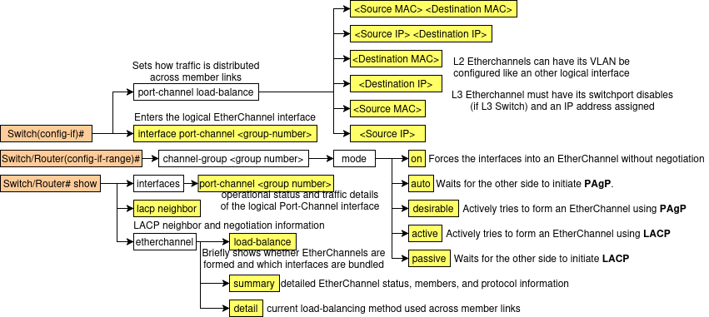

Address Resolution Protocol (ARP)  Purpose: Resolves an IPv4 address to a MAC address on the local network | Packet Types:  Request is a Layer 2 broadcast asking who owns the target IP.  Reply is usually a unicast carrying the sender’s MAC address.  ARP is carried directly in an Ethernet frame, not inside an IP packet.
Network / 3 Layer
General Routing | Longest Prefix Match:  If multiple routes match a destination, the router chooses the route with the most matching network bits. | Route Aggregation / Summarization:  Multiple contiguous routes can be combined into one summary route using the common leftmost bits, reducing routing table size. |  | Wildcard Mask:  An inverted subnet mask used to match address ranges. 0 means bits must match, 1 means bits can vary.
Open Shortest Path First (OSPF)  Purpose: Link-state routing protocol that learns topology and uses Dijkstra SPF to choose lowest-cost paths |  |  | OSPF Process / Phases:  1) Discover neighbors - Routers start by sending Hello packets to the OSPF multicast address to find other OSPF routers on the same link.  2) Down state - No hellos have been received from a neighbor yet, so the router does not know of any active OSPF neighbor on that interface.  3) Init state - A hello packet is received from a neighbor, but the receiving router does not yet see its own Router ID listed in that neighbor’s hello packet.  4) 2-Way state - The router now sees its own Router ID in the neighbor’s hello packet, confirming bidirectional communication. On multiaccess networks, this is also where DR and BDR election takes place. Routers that are neither DR nor BDR become DROTHERs.  5) ExStart state - Routers decide which one will start the database exchange and establish the master-slave relationship for synchronization.  6) Exchange state - Routers exchange DBD (Database Description) packets, which are summaries of their link-state databases, so each router can see what information the other router has.  7) Loading state - If a router finds missing or outdated LSAs after reading the DBDs, it sends an LSR (Link-State Request).  The neighbor responds with an LSU (Link-State Update), and the receiving router confirms with an LSAck (Link-State Acknowledgment).  8) Full state - The routers have fully synchronized their link-state databases and are fully adjacent. At this point, they have enough topology information to run the SPF algorithm. 9) Calculate best paths - Each router runs Dijkstra’s Shortest Path First algorithm on the synchronized database to calculate the lowest-cost routes to remote networks.
OSPF can advertise a default route. Passive interfaces stop hello packets and neighbor formation while still advertising the connected network.
Cost:
Path cost is based on interface bandwidth. Default formula: cost = reference bandwidth / interface bandwidth. Cost can be changed by adjusting reference bandwidth, interface bandwidth, or manual ip ospf cost. Interfaces at 100 Mbps or higher may all appear as cost 1 unless the reference bandwidth is increased.
Packet Types in the Process
Hello: discovers neighbors and maintains adjacency.
DBD: summarizes the link-state database.
LSR: asks for missing or newer LSAs.
LSU: sends the requested or updated LSAs.
LSAck: acknowledges receipt of LSAs.
Areas / Metrics:
OSPF uses areas to reduce database size and processing. Default administrative distance is 110. Supports equal-cost load balancing; default maximum paths is commonly 4.
Router ID / Roles:
Router ID is the highest loopback IP, otherwise highest active interface IP. On multiaccess links, routers elect a DR and BDR by priority, then Router ID.
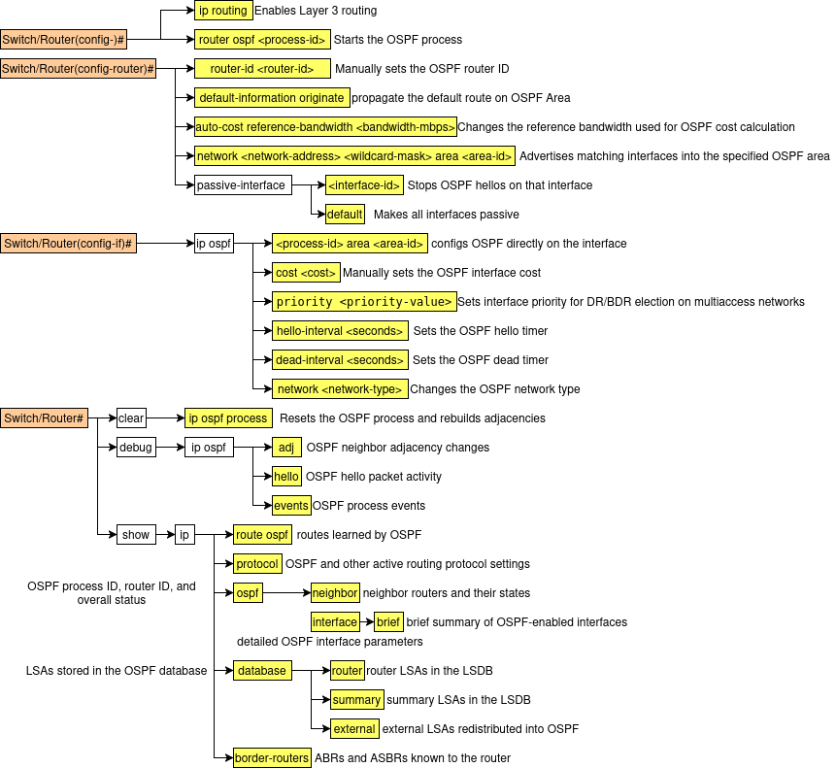

Internet Control Message Protocol (ICMP)  Purpose: Used by IP devices to send error reports and operational / diagnostic messages. | ICMP Type 3 Destination Unreachable Codes  0 Destination network unreachable  1 Destination host unreachable  2 Destination protocol unreachable  3 Destination port unreachable  4 Fragmentation required, and DF flag set  5 Source route failed  6 Destination network unknown  7 Destination host unknown  8 Source host isolated  9 Network administratively prohibited  10 Host administratively prohibited  11 Network unreachable for ToS  12 Host unreachable for ToS  13 Communication administratively prohibited  14 Host precedence violation  15 Precedence cutoff in effect
Common Types:
Type 3 Destination Unreachable
Type 11 Time Exceeded
Type 8 / 0 Echo Request / Echo Reply
Type 13 / 14 Timestamp Request / Reply
Message Categories:
Error messages: report delivery problems.
Query / Reply messages: used for testing and diagnostics.

Network Address Translation (NAT)  Purpose: Translates private IP addresses to public IP addresses for external communication. | Private addresses:  10.0.0.0 – 10.255.255.255  172.16.0.0.0 – 172.31.255.255  192.168.0.0 – 192.168.255.255 | NAT Types:  Static NAT: fixed 1-to-1 private to public mapping.  Dynamic NAT: maps private addresses to a public pool.  PAT / NAT Overload: maps many private hosts to one public IP using different port numbers.
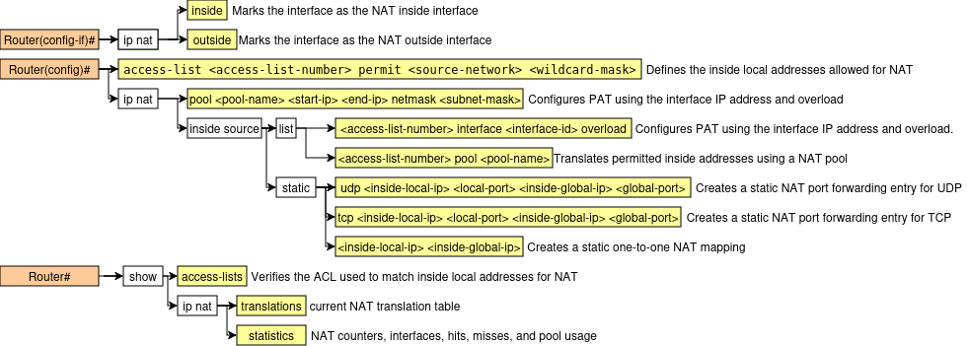

Transport / 4 Layer
TCP - Provides reliable data delivery  Purpose: Reliable, connection-oriented transport protocol. | Services:  Process addressing with port numbers, connection establishment/termination, flow control, error recovery, and congestion control. | Connection Closing: 1) One side sends FIN.  2) The other side replies ACK and sends its own FIN.  3) The first side replies ACK. | Connection Establishment:  1) Client sends SYN with initial sequence number.  2) Server replies SYN-ACK with its own initial sequence number.  3) Client sends ACK to complete the three-way handshake.
TCP Sliding Window  1) The sliding window is the number of bytes the sender can transmit before needing an ACK.  2) TCP uses it for flow control, so the sender does not send more data than the receiver can handle.  3) The receiver advertises a window size, which tells the sender how much buffer space is available.  4) The sender can send all bytes that fit within the current window without stopping after every segment.  5) As data is sent, the available space in the sender’s current window decreases.  6) When an ACK is received, the sender knows some bytes were successfully received.  7) The ACK number tells the sender the next byte expected, meaning all earlier bytes were received.  8) After the ACK arrives, the sender’s allowed sending range moves forward, so the window slides.  9) If the receiver advertises a larger window, the sender can send more data.  10) If the receiver advertises a smaller window, the sender must slow down.  11) If the receiver advertises a window size of 0, the sender must stop sending until the window opens again.  12) Both sender and receiver maintain their own window and buffer information during communication.  13) This improves efficiency because TCP can send multiple segments at once instead of waiting for an ACK after every segment.  14) Example: if the window is 3000 bytes, the sender may send bytes 1–3000. If it later receives ACK 2001, the window slides forward and the sender can continue from byte 2001 onward.  In short, the sliding window is a moving byte range that controls how much unacknowledged data can be in transit at one time. |  |  |  | TCP Error Control  1) TCP uses sequence numbers to track the order of bytes sent.  2) The receiver uses ACKs to confirm which bytes were received successfully.  3) If an ACK is not received within the Retransmission Timeout (RTO), TCP assumes the segment or ACK was lost.  4) The sender then retransmits the missing segment.  5) If segments arrive out of order, TCP uses sequence numbers to place them in the correct order.  6) If a segment is duplicated, TCP can detect it because the sequence number was already received.  7) If data is corrupted, the checksum helps detect the error, and the bad segment is discarded.  8) Since the corrupted segment is not acknowledged properly, the sender retransmits it.  9) This process allows TCP to recover from lost, damaged, duplicate, or out-of-order segments.  10) Overall, TCP error control provides reliable delivery by detecting problems and retransmitting data when needed.
UDP  Purpose: Fast, connectionless transport protocol. | Characteristics:  Provides low-overhead, best-effort delivery with no connection setup, no reliability, no retransmission, and no flow control. It is datagram-oriented.

Application / 7 Layer
Dynamic Host Configuration Protocol (DHCP)  Purpose: Dynamically assigns IP addressing information to hosts. | DHCP Relay Agent:  A relay agent forwards client DHCP broadcasts to a DHCP server on another network by replacing the destination address with the server’s address. | Ports / Transport:  Uses UDP.  Server: port 67  Client: port 68
TCP Error Control
- TCP uses sequence numbers to track the order of bytes sent.
- The receiver uses ACKs to confirm which bytes were received successfully.
- If an ACK is not received within the Retransmission Timeout (RTO), TCP assumes the segment or ACK was lost.
- The sender then retransmits the missing segment.
- If segments arrive out of order, TCP uses sequence numbers to place them in the correct order.
- If a segment is duplicated, TCP can detect it because the sequence number was already received.
- If data is corrupted, the checksum helps detect the error, and the bad segment is discarded.
- Since the corrupted segment is not acknowledged properly, the sender retransmits it.
- This process allows TCP to recover from lost, damaged, duplicate, or out-of-order segments.
- Overall, TCP error control provides reliable delivery by detecting problems and retransmitting data when needed.
DNS  Purpose: Resolves domain names to IP addresses so hosts can find network resources by name. | Common Records:  A: maps name to IPv4 address.  AAAA: maps name to IPv6 address.  CNAME: alias to another name.  MX: mail server for a domain.  NS: authoritative name server.  PTR: reverse lookup from IP to name.  TXT: text information. | Resolution Process:  - Client sends a DNS query for a domain name.  - DNS server replies with the matching record if known.  - If not known, the server may query other DNS servers to find the answer.  - The final reply returns the requested record, such as an IP address.
Ports / Transport:
Uses UDP 53 for most queries and replies.
Uses TCP 53 for zone transfers and sometimes large responses.

Layer 2 – Network Access Layer

VLAN

Configuration Steps
- Create the VLAN in the switch VLAN database.
- (Optional) Assign a name to the VLAN for easier identification.
- Configure switch ports connected to end devices as access ports.
- Assign the access ports to the correct VLAN.
- Configure links between switches as trunk ports.
- (Optional) Set trunk encapsulation type if the platform requires it.
- (Optional) Configure the native VLAN for the trunk.
- (Optional) Specify which VLANs are allowed across the trunk.
- Verify VLAN configuration and trunk operation.

Troubleshooting Steps
- Verify the VLAN exists in the VLAN database.
- Check the VLAN assigned to the access port.
- Verify trunk links are operational.
- Ensure the VLAN is allowed across the trunk.
- Check for native VLAN mismatches between switches.
- Confirm MAC addresses are being learned on the correct VLAN.

Rapid Spanning Tree Protocol (RSTP)

Configuration Steps
- Enable spanning tree protocol on the switch.
- Select the spanning tree mode (RSTP / Rapid-PVST).
- (Optional) Configure bridge priority to influence root bridge election.
- (Optional) Configure a secondary root bridge for redundancy.
- (Optional) Enable PortFast on ports connected to end devices.
- (Optional) Enable BPDU Guard on access ports.
- (Optional) Adjust port cost or priority to influence path selection.

Troubleshooting Steps
- Identify the current root bridge.
- Verify port roles (root port, designated port, alternate port).
- Check for ports blocked by spanning tree.
- Verify redundant links are operating correctly.
- Ensure no Layer 2 loops are present.
- Check spanning tree timers and priority settings.

EtherChannel

Configuration Steps
- Select interfaces that will participate in the EtherChannel.
- Ensure all interfaces have identical configurations (speed, duplex, VLAN).
- Choose EtherChannel negotiation protocol (Static, PAgP, or LACP).
- Assign interfaces to the same channel group.
- Configure the logical Port-Channel interface.
- (Optional) Configure trunk or access mode on the port-channel interface.
- Verify EtherChannel formation and status.

Troubleshooting Steps
- Verify interface configurations match across all member links.
- Confirm both sides use the same negotiation protocol.
- Check that member interfaces are active.
- Verify VLAN configuration consistency across the bundle.
- Ensure the logical port-channel interface is operational.
- Confirm STP treats the EtherChannel as a single logical link.

Layer 3 – Internet Layer

Inter-VLAN Routing

Configuration Steps
- Create VLANs on the switch.
- Configure trunking between the switch and router or Layer 3 switch.
- Create subinterfaces (router-on-a-stick) or SVIs.
- Assign IP addresses to VLAN interfaces.
- Enable Layer 3 routing on the device.
- Configure hosts with the VLAN interface as their default gateway.

Troubleshooting Steps
- Verify VLAN interfaces are active.
- Confirm correct IP addresses and subnet masks.
- Check trunk connectivity between switch and router.
- Verify hosts have the correct default gateway.
- Ensure routing is enabled.
- Test connectivity between VLANs.

ARP

Configuration Steps
- Configure IP addresses on devices.
- Ensure devices are on the same subnet or reachable through routing.
- Devices send ARP requests to discover MAC addresses.
- Destination devices reply with their MAC address.
- The mapping is stored in the ARP table.

Troubleshooting Steps
- Check ARP table entries for correct mappings.
- Verify the destination device is reachable on the network.
- Ensure no duplicate IP addresses exist.
- Verify correct subnet masks.
- Confirm switching and VLAN operation.

OSPF

Configuration Steps
- Enable Layer 3 routing on the router.
- Start the OSPF routing process.
- Configure the router ID.
- Advertise networks using network statements and wildcard masks.
- Assign networks to the correct OSPF areas.
- (Optional) Configure interface parameters (cost, priority, timers).
- Allow routers to discover neighbors through Hello packets.
- Establish adjacency and synchronize the link-state database.
- Calculate best paths using the SPF algorithm.

Troubleshooting Steps
- Verify OSPF neighbor adjacency.
- Check routers are in the same OSPF area.
- Confirm hello and dead timers match.
- Verify network advertisements are correct.
- Ensure router IDs are unique.
- Check the link-state database synchronization.
- Confirm routes appear in the routing table.

NAT

Configuration Steps
- Identify inside and outside interfaces.
- Define internal address ranges for translation.
- Choose NAT type (static NAT, dynamic NAT, or PAT).
- Configure public address or address pool.
- Apply translation rules.
- Verify NAT translations.

Troubleshooting Steps
- Verify correct inside/outside interface designation.
- Check NAT translation table entries.
- Confirm access lists permit the correct traffic.
- Verify connectivity to the external network.
- Ensure routing to the public network is correct.

DHCP

Configuration Steps
- Define the DHCP address pool.
- Configure the network and subnet mask for the pool.
- Specify the default gateway for clients.
- (Optional) Configure DNS server addresses.
- (Optional) Exclude reserved addresses from the pool.
- Enable the DHCP service on the server or router.
- Configure hosts to obtain IP addresses automatically.

Troubleshooting Steps
- Verify DHCP server service is running.
- Check the DHCP address pool for available addresses.
- Ensure clients are configured for automatic IP assignment.
- Verify DHCP messages (Discover, Offer, Request, Acknowledge).
- Confirm routing or relay configuration if the server is on another network.
- Check that no IP address conflicts exist.

OSPF Packet Types

